**Digital Nurture 4.0 Week 7**

**REACT**

**Mandatory Hands On**

**File name: 9. ReactJS-HOL**

**Step 1:**

* Node.js & NPM installed
* VS Code installed

Then, run:

npx create-react-app cricketapp

cd cricketapp

npm start

**Step 2: ListofPlayers.js**

import React from 'react';

const ListofPlayers = () => {

const players = [

{ name: 'Virat Kohli', score: 85 },

{ name: 'Rohit Sharma', score: 90 },

{ name: 'Shubman Gill', score: 60 },

{ name: 'KL Rahul', score: 55 },

{ name: 'Hardik Pandya', score: 45 },

{ name: 'Jadeja', score: 88 },

{ name: 'Rishabh Pant', score: 70 },

{ name: 'Ashwin', score: 30 },

{ name: 'Bumrah', score: 80 },

{ name: 'Shami', score: 95 },

{ name: 'Surya Kumar', score: 65 }

];

const lowScorers = players.filter(player => player.score < 70);

return (

<div>

<h2>All Players:</h2>

<ul>

{players.map((player, index) => (

<li key={index}>{player.name} - {player.score}</li>

))}

</ul>

<h3>Players with Score Below 70:</h3>

<ul>

{lowScorers.map((player, index) => (

<li key={index}>{player.name} - {player.score}</li>

))}

</ul>

</div>

);

};

export default ListofPlayers;

**Step 3: IndianPlayers.js**

import React from 'react';

const IndianPlayers = () => {

const team = [

'Kohli', 'Rohit', 'Gill', 'Rahul',

'Pandya', 'Jadeja', 'Pant', 'Ashwin',

'Bumrah', 'Shami', 'Surya'

];

const oddTeam = team.filter((_, index) => index % 2 !== 0);

const evenTeam = team.filter((_, index) => index % 2 === 0);

const T20players = ['Virat', 'Rohit', 'Pant'];

const RanjiTrophyPlayers = ['Rahane', 'Pujara', 'Saha'];

const mergedPlayers = [...T20players, ...RanjiTrophyPlayers];

return (

<div>

<h2>Odd Team Players:</h2>

<ul>{oddTeam.map((name, i) => <li key={i}>{name}</li>)}</ul>

<h2>Even Team Players:</h2>

<ul>{evenTeam.map((name, i) => <li key={i}>{name}</li>)}</ul>

<h2>Merged Players (T20 + Ranji):</h2>

<ul>{mergedPlayers.map((name, i) => <li key={i}>{name}</li>)}</ul>

</div>

);

};

export default IndianPlayers;

**Step 4:App.js**

import React from 'react';

import ListofPlayers from './components/ListofPlayers';

import IndianPlayers from './components/IndianPlayers';

function App() {

return (

<div className="App">

<h1>🏏 Cricket App using ES6 Features</h1>

<ListofPlayers />

<IndianPlayers />

</div>

);

}

export default App;

Output:

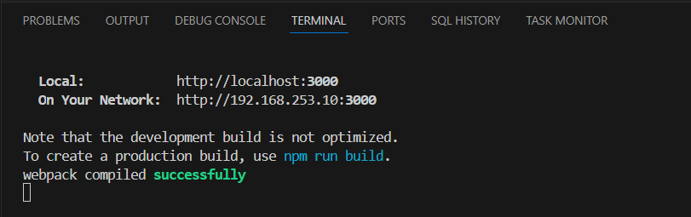

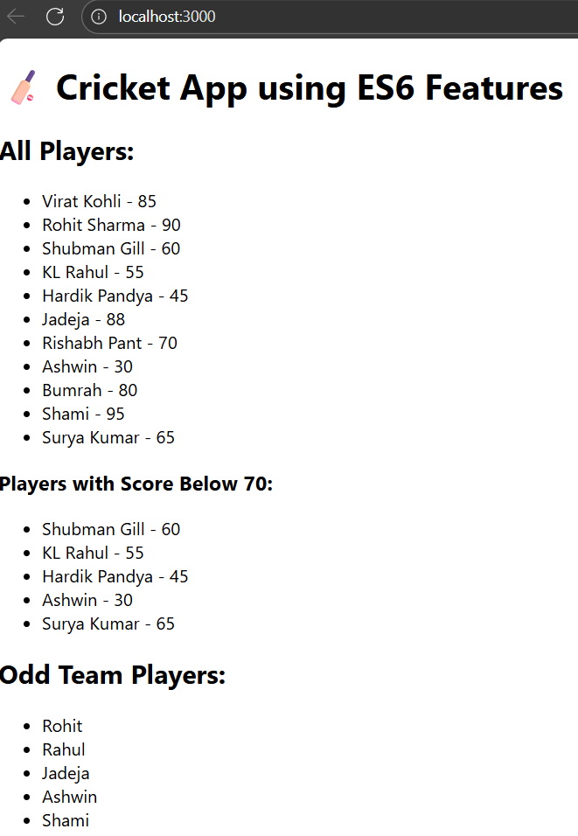

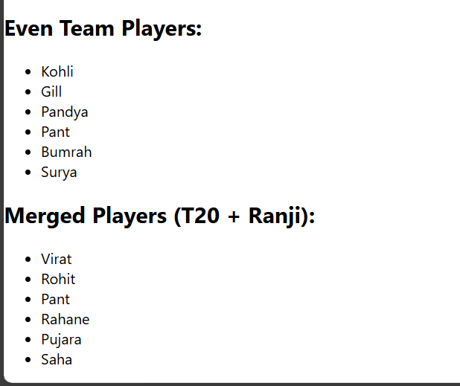

**File name: 10. ReactJS-HOL**

**Step 1: Create the React App**

npx create-react-app officespacerentalapp

cd officespacerentalapp

npm start

**Step 2: App.js**

Replace everything inside App.js with the following:

import React from 'react';

const headingStyle = {

color: 'darkblue',

fontSize: '32px',

textAlign: 'center',

marginTop: '20px'

};

const imageStyle = {

width: '60%',

borderRadius: '10px',

display: 'block',

margin: '20px auto'

};

const singleOffice = {

name: "Skyline Tower",

rent: "₹40,000/month",

address: "123, MG Road, Bangalore"

};

const officeList = [

{

name: "Green Park",

rent: "₹25,000/month",

address: "Anna Salai, Chennai"

},

{

name: "Ocean View",

rent: "₹50,000/month",

address: "Marine Drive, Mumbai"

},

{

name: "Tech Plaza",

rent: "₹35,000/month",

address: "Hitech City, Hyderabad"

}

];

function App() {

return (

<div className="App">

{/* JSX heading element */}

<h1 style={headingStyle}>🏢 Office Space Rental App</h1>

{/* JSX image with attributes */}

<img

style={imageStyle}

src="https://images.unsplash.com/photo-1598327105666-5b89351aff97"

alt="Office space"

/>

{/* Displaying one object */}

<div style={{ textAlign: 'center', marginBottom: '30px' }}>

<h2>{singleOffice.name}</h2>

<p><strong>Rent:</strong> {singleOffice.rent}</p>

<p><strong>Address:</strong> {singleOffice.address}</p>

</div>

{/* Loop through list of office objects */}

<h2 style={{ textAlign: 'center' }}>Available Office Spaces</h2>

<ul>

{officeList.map((office, index) => (

<li key={index} style={{ marginBottom: '20px', padding: '10px', borderBottom: '1px solid #ccc' }}>

<h3>{office.name}</h3>

<p><strong>Rent:</strong> {office.rent}</p>

<p><strong>Address:</strong> {office.address}</p>

</li>

))}

</ul>

</div>

);

}

export default App;

Output:

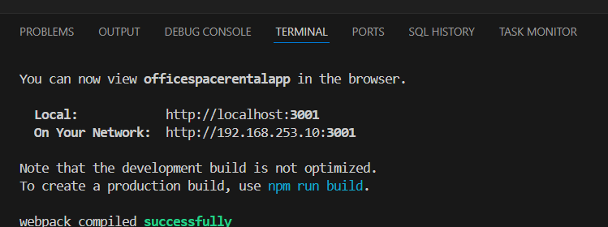

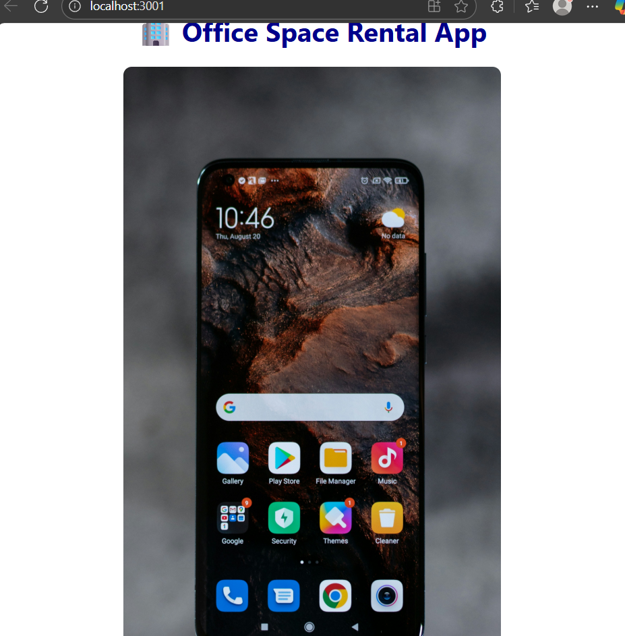

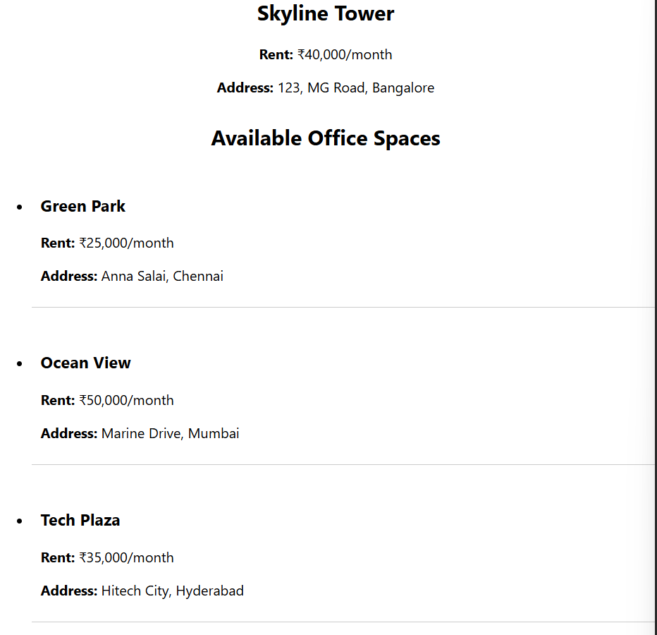

**File name: 11. ReactJS-HOL**

**Step 1: Create the React App**

npx create-react-app eventexamplesapp

cd eventexamplesapp

npm start

**Step 2: Counter Component**

Handles multiple methods and uses this, event handlers, and React naming conventions.

**components/Counter.js**

import React, { Component } from 'react';

class Counter extends Component {

constructor(props) {

super(props);

this.state = {

count: 0

};

this.increment = this.increment.bind(this);

this.sayHello = this.sayHello.bind(this);

this.handleIncrease = this.handleIncrease.bind(this);

}

increment() {

this.setState({ count: this.state.count + 1 });

}

decrement = () => {

this.setState({ count: this.state.count - 1 });

}

sayHello() {

alert("Hello! Incremented the value.");

}

handleIncrease() {

this.increment();

this.sayHello();

}

render() {

return (

<div>

<h2>Counter Value: {this.state.count}</h2>

<button onClick={this.handleIncrease}>Increase</button>

<button onClick={this.decrement}>Decrease</button>

</div>

);

}

}

export default Counter;

**Step 3: WelcomeButton Component**

Demonstrates event handler with arguments.

**components/WelcomeButton.js**

import React from 'react';

function WelcomeButton() {

const sayMessage = (msg) => {

alert(msg);

};

return (

<button onClick={() => sayMessage("Welcome!")}>Say Welcome</button>

);

}

export default WelcomeButton;

**Step 4: ClickMessage Component**

Demonstrates **synthetic event** handling in React.

**components/ClickMessage.js**

import React from 'react';

function ClickMessage() {

const handleClick = (event) => {

alert("I was clicked!");

console.log("Synthetic Event Type:", event.type

};

return (

<button onClick={handleClick}>Click Me (Synthetic Event)</button>

);

}

export default ClickMessage;

**Step 5: CurrencyConvertor Component**

Converts INR to Euro using a simple input + event handling.

**components/CurrencyConvertor.js**

import React, { useState } from 'react';

function CurrencyConvertor() {

const [rupees, setRupees] = useState("");

const [euro, setEuro] = useState(null);

const convertToEuro = () => {

const inr = parseFloat(rupees);

if (!isNaN(inr)) {

const conversionRate = 0.011;

setEuro((inr * conversionRate).toFixed(2));

} else {

alert("Please enter a valid number");

}

};

return (

<div>

<h3>Currency Convertor (INR to Euro)</h3>

<input

type="text"

placeholder="Enter INR"

value={rupees}

onChange={(e) => setRupees(e.target.value)}

/>

<button onClick={convertToEuro}>Convert</button>

{euro && <p>€ {euro}</p>}

</div>

);

}

export default CurrencyConvertor;

**Step 6:App.js**

import React from 'react';

import Counter from './components/Counter';

import WelcomeButton from './components/WelcomeButton';

import ClickMessage from './components/ClickMessage';

import CurrencyConvertor from './components/CurrencyConvertor';

function App() {

return (

<div className="App" style={{ padding: '20px' }}>

<h1>🧪 React Event Handling Examples</h1>

<Counter />

<hr />

<WelcomeButton />

<hr />

<ClickMessage />

<hr />

<CurrencyConvertor />

</div>

);

}

export default App;

**OUTPUT:**

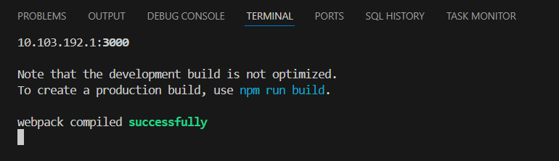

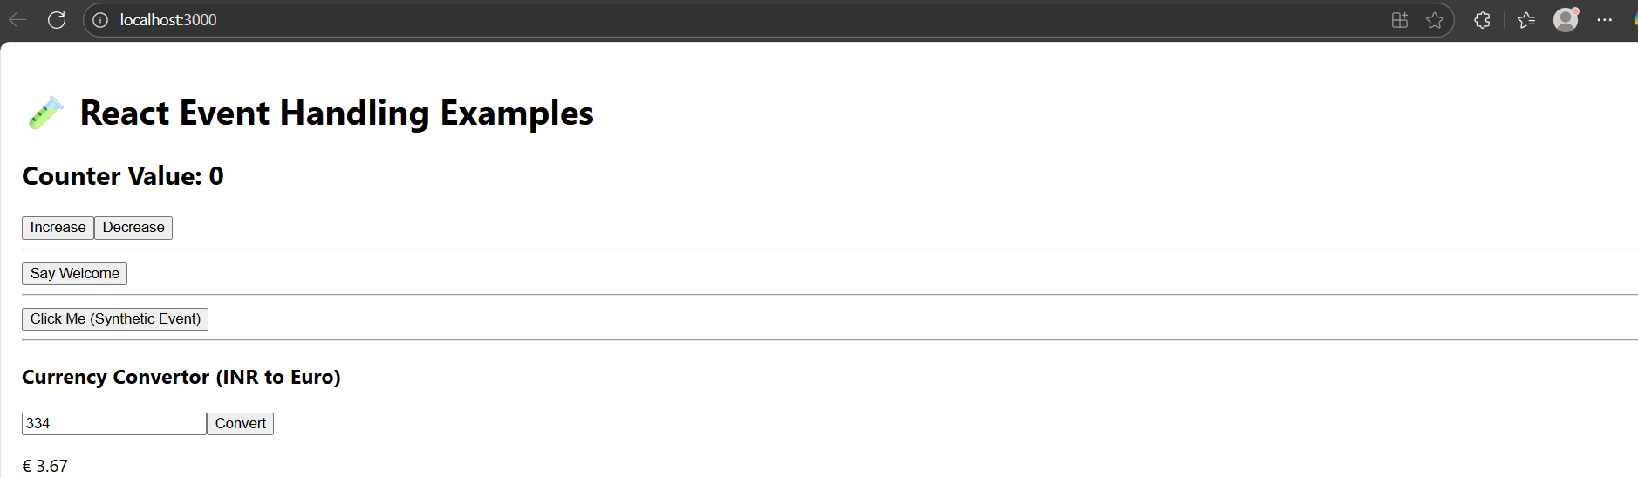

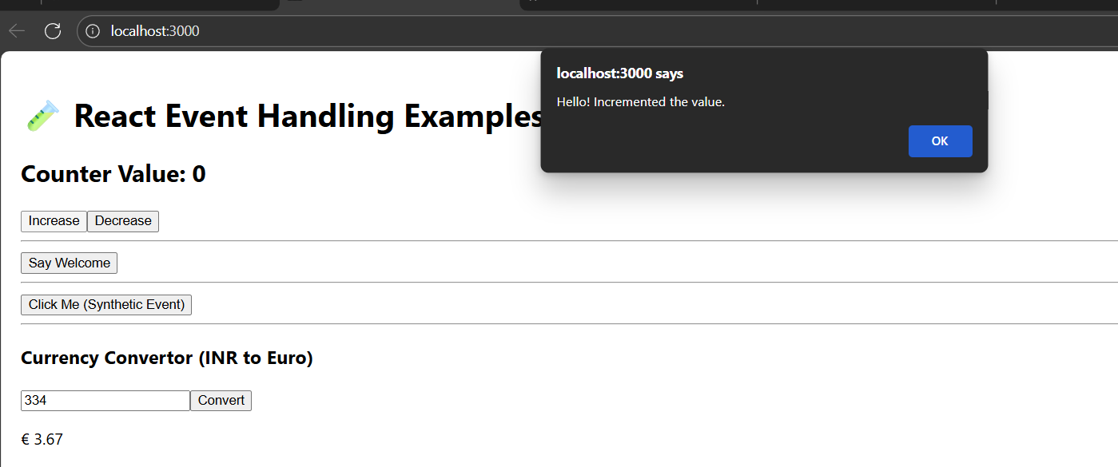

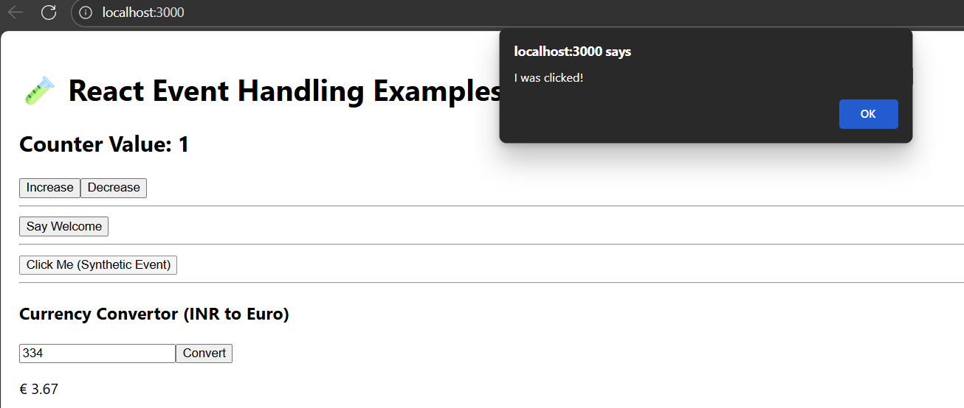

**File name: 12. ReactJS-HOL**

**Step 1: Create a react app**

npx create-react-app ticketbookingapp

cd ticketbookingapp

npm start

**Step 2: FlightDetails.js – Guest view**

import React from 'react';

function FlightDetails() {

return (

<div>

<h2>✈️ Available Flights</h2>

<ul>

<li>Chennai → Delhi - ₹4500</li>

<li>Bangalore → Mumbai - ₹3800</li>

<li>Hyderabad → Kolkata - ₹4100</li>

</ul>

</div>

);

}

export default FlightDetails;

**Step 3: UserDashboard.js – Logged-in view**

import React from 'react';

function UserDashboard() {

return (

<div>

<h2>🎫 Book Your Ticket</h2>

<p>Welcome, user! You can now book tickets.</p>

<button>Book Now</button>

</div>

);

}

export default UserDashboard;

**Step 4: App.js – Main logic for conditional rendering**

import React, { useState } from 'react';

import FlightDetails from './components/FlightDetails';

import UserDashboard from './components/UserDashboard';

function App() {

const [isLoggedIn, setIsLoggedIn] = useState(false);

let button;

if (isLoggedIn) {

button = <button onClick={() => setIsLoggedIn(false)}>Logout</button>;

} else {

button = <button onClick={() => setIsLoggedIn(true)}>Login</button>;

}

return (

<div className="App" style={{ padding: '20px' }}>

<h1>🛫 Ticket Booking App</h1>

{button}

<hr />

{/* Conditional Rendering */}

{

isLoggedIn ? <UserDashboard /> : <FlightDetails />

}

{/* Prevent component rendering (example) */}

{

!isLoggedIn && <p style={{ color: 'gray' }}>Login to book your tickets.</p>

}

</div>

);

}

export default App;

**Output:**

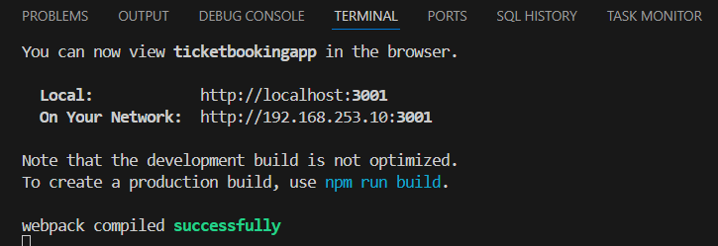

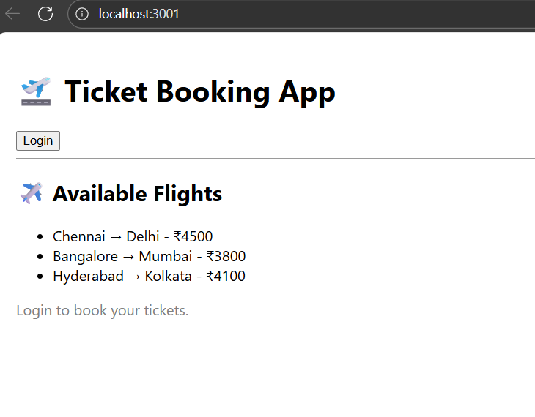

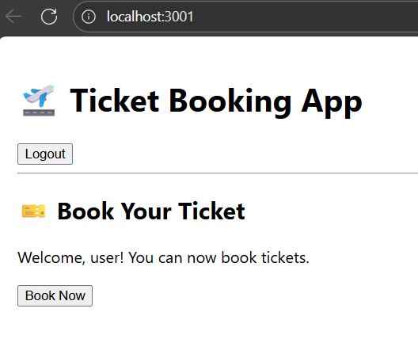

**File name: 13. ReactJS-HOL**

**Step 1: Create the React App**

npx create-react-app bloggerapp

cd bloggerapp

npm start

**Step 2: BookDetails.js**

import React from 'react';

function BookDetails({ books }) {

return (

<div>

<h2>📚 Book Details</h2>

<ul>

{books.map((book, index) => (

<li key={index}>

<strong>{book.title}</strong> - {book.author}

</li>

))}

</ul>

</div>

);

}

export default BookDetails;

**Step 3: BlogDetails.js**

import React from 'react';

function BlogDetails({ blogs }) {

return (

<div>

<h2>📝 Blog Details</h2>

{blogs.length === 0 ? (

<p>No blogs available.</p>

) : (

blogs.map((blog) => (

<div key={blog.id} style={{ marginBottom: '10px' }}>

<h4>{blog.title}</h4>

<p>{blog.content}</p>

</div>

))

)}

</div>

);

}

export default BlogDetails;

**Step 4: CourseDetails.js**

import React from 'react';

function CourseDetails({ courses }) {

if (!courses || courses.length === 0) return null; // Prevent rendering

return (

<div>

<h2>🎓 Course Details</h2>

<ul>

{courses.map((course, index) => (

<li key={index}>

<b>{course.name}</b> - Duration: {course.duration}

</li>

))}

</ul>

</div>

);

}

export default CourseDetails;

**Step 5: App.js**

import React, { useState } from 'react';

import BookDetails from './components/BookDetails';

import BlogDetails from './components/BlogDetails';

import CourseDetails from './components/CourseDetails';

function App() {

const [section, setSection] = useState('books');

// Data

const books = [

{ title: 'React in Action', author: 'Mark T.' },

{ title: 'Learning React', author: 'Alex B.' }

];

const blogs = [

{ id: 1, title: 'React Basics', content: 'Learn JSX, components, props...' },

{ id: 2, title: 'Hooks in Depth', content: 'Explore useState, useEffect...' }

];

const courses = [

{ name: 'ReactJS', duration: '6 weeks' },

{ name: 'JavaScript Advanced', duration: '4 weeks' }

];

// Conditional Rendering: Switch Statement (alternative approach)

const renderSection = () => {

switch (section) {

case 'books':

return <BookDetails books={books} />;

case 'blogs':

return <BlogDetails blogs={blogs} />;

case 'courses':

return <CourseDetails courses={courses} />;

default:

return <p>Please select a section.</p>;

}

};

return (

<div className="App" style={{ padding: '20px' }}>

<h1>🧠 Blogger App</h1>

{/* Conditional Buttons */}

<button onClick={() => setSection('books')}>Show Books</button>

<button onClick={() => setSection('blogs')}>Show Blogs</button>

<button onClick={() => setSection('courses')}>Show Courses</button>

<hr />

{/* Element Variable with Conditional Rendering */}

{renderSection()}

{/* Inline Ternary Example */}

<p style={{ marginTop: '20px', fontStyle: 'italic' }}>

{section === 'books'

? 'Reading is essential for growth.'

: section === 'blogs'

? 'Keep blogging, keep learning!'

: 'Enroll in a course to upskill yourself.'}

</p>

</div>

);

}

export default App;

**Output:**